VIsual and Statistical Data Analyzer (VISDA)

Requirements and Specification Document
Software Requirements Specification

Version 1.2

Document Change Record
Version Number | Date | Description
1.0 | April 22, 2005 | First Draft
1.1 | May 20, 2005 | Updated document as per adopter’s comments
1.2 | May 24, 2005 | Updated document as per Arch comments
1.2.1 | May 31, 2005 | Updated document as per Arch comments
1.2.2 | June 3, 2005 | Updated document as per VCDE and NCICB’s comments
1.0 | June 6, 2005 | First Draft of Final Version
1.1 | July 19, 2005 | Updated document of Final Version per VCDE’s comments
1.2 | August 10, 2005 | Corrected typos in Final Version per VCDE’s comments
1.2 | October 12, 2005 | Updated Final Version

TABLE OF CONTENTS
1. Introduction 1
1.1 Scope 1
1.1.1 Identification 2
1.1.2 System Overview 2
1.1.3 Document Overview 2
1.2 Reference Documents 2
2. Project Description 4
2.1 Project Perspective 4
2.2 Project Functions 4
2.3 User Characteristics 4
2.4 Constraints 4
2.5 Qualification Provisions 5
2.6 Assumptions and Dependencies 5
3. Requirements 6
3.1 END USER REQUIREMENTS 6
3.2 JAVA GUI INTERFACE 7
3.3 VISDA DATA PREPROCESSING 7
3.4 VISDA CORE ENGINE 7
3.5 VISDA VISULIZATION 8
4. System Architecture 9
4.1 System Architecture Overview 9
4.2 Architectural Design 9
4.2.1 VISDA GUI Engine 9
4.2.2 VISDA Preprocessing Engine 10
4.2.3 VISDA Visualization Engine 10
4.2.4 VISDA Core Engine 10
5. Components 11
5.1 VISDA GUI Module 11
5.1.1 Visda 11
5.1.2 MainFrame 11
5.1.3 ConfigDialog 12
5.2 VISDA data preprocessing Module 13
5.2.1 MicroarrayDataInput 13
5.2.2 DataManager 14
5.2.3 FeaturePreSelector 16
5.3 VISDA core Module 17
5.3.1 DRMCore 17
5.3.2 CFMCore 19
5.3.3 CVMCore 20
5.4 VISDA Visulization Module 21
5.4.1 TreeViewTools 21
5.4.2 2DPlotTools 21
5.5 VISDA utilitieS Module 22
5.5.1 SwingWorker 22
5.5.2 MathTools 22
5.5.3 HCTools 23
5.5.4 FCTools 25
6. Sign off 27
6.1 Approval 27
Appendix A – Acronym List 28
Appendix B – Detail DescriptioN of visda core engine 29

Introduction
Multivariate visualization has proven to be a powerful yet critical tool for the analysis and interpretation of complex high-dimensional data. To reveal all of the interesting patterns within a data set, we have developed a VIsual and Statistical Data Analyzer (VISDA) for cluster modeling, discovery, and visualization. VISDA is capable of navigating into a high dimensional data set to discover the hidden clustered data structure, and model and visualize the discovery. It is particularly effective when dealing with highly complex data sets as compared to conventional methods. To reveal all of the hidden clusters, our exploration of high-dimensional data space is both statistically-principled and visually-insightful. Our method can incorporate both the power of statistical methods and the human gift for pattern recognition, and is capable of capturing progressively all interesting aspects of the data set. Most importantly, the outcomes of VISDA form a “tree of phenotype” which enables global and local biomarker identification and assessment. The main applications of VISDA can be found in microarray data analysis, proteomics data analysis, and clinical data analysis, etc. For example, define new cancer subtypes based on their gene expression patterns, construct hierarchical trees of multiclass cancer phenotypic composite, or discover the correlation between cancer statistics and risk factors.
This SRSD captures the complete software requirements for the VISDA system and describes the design decisions, architectural design and the detailed design needed to implement the software. It provides the acquirer visibility in to the design and provides information needed for software support. The audience of this document is designers of the system and testers of the system.

Scope
The primary objective of this proposed project is to adapt/convert the VIsual and Statistical Data Analyzer (VISDA) software to the cancer Biomedical Informatics Grid (caBIG) architecture to allow users across the cancer research community to analyze their own molecular expression data as well as “grid” data using this powerful tool for clustering modeling, discovery, and visualization. The resulting software will be open-source in C++/Java compatible at the Silver maturity level of the caBIG. As part of the Integrative Cancer Research (ICR) Workspace, the project will be a demonstration of how a shared informatics platform and expertise can allow a comprehensive, federated grid of informatics tools to be made available to the cancer research community.
The proposed development of open-source VISDA software will build upon the current computational/statistical bioinformatics expertise at the Computational Bioinformatics and Bioimaging Laboratory (CBIL) (http://www.cbil.ece.vt.edu) affiliated with the Georgetown University Lombardi Cancer Center. The VISDA software will support the mission of caBIG-ICR in that the development is tasked to develop a well-documented and validated toolset for use throughout the cancer research community.
As part of the caBIG-ICR workspace, VISDA will be 1) deployed to the Adopter site(s) for analysis; 2) adapted to the caBIG architecture; and 3) enhanced with a graphical user interface to improve usability.

This document describes, in detail the proposed object components that will be deployed as part of VISDA system.

Identification
This SRSD document refers to version 1.0-alpha of the VISDA system.

System Overview
VISDA can navigate into a high dimensional microarray data set to discover the hidden clustered data structure, and model and visualize the discovery. VISDA incorporates both the power of statistical methods and the human interaction, and is capable of capturing progressively all interesting aspects of the data set. Input is a microarray data loaded from local pre-defined tab-delimited format file in Stanford text format, local MAGE-ML file, or from caArray database, with common gene identifiers and sample names. The gene identifiers can be any the approved list that the ICR Genome Annotation SIG has compiled. Access to these can be found at: http://cdebrowser.nci.nih.gov/CDEBrowse. Outputs are the “soft-clustering” probabilities of the samples/genes in each cluster and a hierarchical “tree of phenotype” or “tree of gene module”.

Document Overview
This SRSD captures the complete software requirements for the Visual and Statistical Data Analyzer software for combining microarray data sets, release version 1.0-alpha, as part of the Integrative Cancer Research Workspace of the caBIG™ program. Requirements and procedural instructions are included in the Standard Operating Procedures (SOPs).
All software will be completely open source, as outlined under the GNU General Public License. There are no additional security or privacy considerations.
The remaining SRSD sections are organized as follows:
- Section 2. Project Description: Describes the general factors that affect the VISDA system.
- Section 3. Requirements: Describes all the software requirements to a level of detail sufficient to enable designers to design a system to satisfy those requirements, and testers to test that the system satisfies those requirements.
- Section 4. System Architecture: Explains the high-level concept of the system. Summarize the system context and system design, with diagrams.
- Section 5. Components: Describes each software unit of the requirement to a level of detail sufficient to enable designers to implement a system to satisfy those requirements.
- Appendix A. Acronym List: Defines the abbreviations used on the project.
- Appendix B. Detail Description of VISDA Core Engine: Describes the VISDA core engines in detail.

Reference Documents
The documents and publications for additional project and requirement specific information are available from caBIG CVS repository for VISDA at “http://cabigcvs.nci.nih.gov/viewcvs/viewcvs.cgi/visda”. The relevant documents and publications include:

- VISDA statement of work (SOW)
- VISDA project use cases
- VISDA project risk management matrix
- VISDA UML class diagrams
- Y. Wang, L. Luo, M. T. Freedman, and S. Y. Kung, “Probabilistic principal component subspaces: a hierarchical finite mixture model for data visualization,” IEEE Transactions on Neural Networks, vol. 11, no. 3, pp. 635-646, May 2000.
- Z. Wang, Y. Wang, J. Lu, S-Y Kung, J. Zhang, R. Lee, J. Xuan, J. Khan, and R. Clarke, “Discriminatory mining of gene expression microarray data,” Journal of VLSI Signal Processing, vol. 35, no. 3, pp. 255-272, Nov. 2003.

Project Description

Project Perspective
VISDA is a graphical, interactive desktop application. It can run on any platform that supports Java JRE 5.0 and C compiler. The suggested RAM is 256MB or above. CPU is 1.0 GMHz or above.

Components of VISDA communicate with caArray instances.

Project Functions
The functionality of VISDA that will be implemented in Java/C is summarized as follows:
- Cluster modeling using hierarchical standard final normal mixture (HSFNM) models
- Dimension reduction by principal component analysis (PCA), discriminatory component analysis (DCA) and project pursuit method (PPM)
- Cluster formation by soft data clustering using expectation-maximization (EM) algorithm
- Cluster validation by minimum description length (MDL) criterion
- Cluster visualization by hierarchical cluster display
- Graphical user interface (GUI) for VISDA set-up, data input-output, data analysis, and data/results visualization
The functionality of VISDA will be packaged as several components using UML design and can be called through well-defined APIs and interact with caArray by wrapping MAGE-OM APIs.

User Characteristics
This project targets users that have a biological background as well as basic knowledge to use computer software with GUI. It is expected that the target users will have better understanding of high-dimensional biological data structure and generate new hypothesis for their research by using VISDA. For example, define new cancer subtypes based on their gene expression patterns, construct hierarchical trees of multiclass cancer phenotypic composite, or discover the correlation between cancer statistics and risk factors.

Constraints
The software components are constrained by caArray MAGE-OM APIs. In order to import processed (normalized) microarray datasets and Common Data Elements (CDE) needed in VISDA, the developer must implement function wrappers to utilize caArray MAGE-OM APIs. Most components of VISDA are written in the Java programming language. There are a few computational components which are written in C/C++. Such components are platform-dependent and need to be compiled before deployment.

Qualification Provisions
Three qualification methods will be used in VISDA project:
- Test
Qualification of the operation of the system and its components will be done through unit testing and system testing based on test approach document. This will be done for all of the Requirement IDs (defined in Section 3).
- Visual Inspection
Visual inspection will be done for the GUI layout. In Section 3, the GUI layout appears in requirement IDs: 3.2.1, 3.2.2, and 3.2.3.
- Statistical Analysis
Additional qualification through statistical analysis will be done for the array clustering with known labeling, indexed in Section3, as Requirement ID: 3.1.1

Assumptions and Dependencies
VISDA requires:
- Any platform that supports Java JRE 5.0 and C compiler
- Input microarray data should be normalized expression values.
- Importing data from caArray to VISDA is dependent on caArray MAGE-OM APIs.
- Importing data from local MAGE-ML file to VISDA is dependent on MAGEstk (The MAGE Software Toolkit).
- BLAS, routines for performing basic vector and matrix operations.
- JAMA, a Java matrix package.
- JMATHPLOT, a Java plotting package.
- EPSGRAPHICS, a Java EPS file saving package.
- This project is completely open source, according to the GNU General Product License.

Requirements
Requirements for this project fall into two main categories:
- End user requirements
- System requirements
End user requirements are those requirements that specific end users or groups of end users request. These requirements have been gathered and discussed over a series of teleconferences and face-to-face meetings with the adopters from Showe Lab, Wistar Institute, the University of Pennsylvania. Other end user requirements have been taken from years of producing the VISDA, listening to end user scenarios and meeting internal system objectives. End user requirements or scenarios are captured and analyzed to produce use cases in the “VISDA use cases” document.
System requirements manifest themselves after the elaboration of the end user requirements is completed. These system requirements are enumerated below and in the use cases already submitted to the NCI and VISDA adopters.

END USER REQUIREMENTS
Table 3.1: End User Requirements
Req ID | Requirement Type | Requirement Description | CCR # (Optional) | Trace from User Requirement/  Trace to System Requirement (Optional)
3.1.1 | End User | Have an option to do array clustering
3.1.2 | End User | Have an option to do gene clustering
3.1.3 | End User | Have an option to set the depth of the hierarchical level
3.1.4 | End User | Have an option to set the distance and linkage methods when performing hierarchical clustering as the preprocessing of DCA in VISDA
3.1.5 | End User | Let the user control the depth of sub clustering for a particular cluster of interest without having to go through the same steps for other clusters
3.1.6 | End User | Let the user specify the directory for saving output results generated from VISDA
3.1.7 | End User | Output a table of the most informative genes selected for array clustering with its ranked by SNR (supervised) or variance (unsupervised) criteria
3.1.8 | End User | Output tables of all sample names and the clustering posterior probabilities of all samples belonging to all clusters under each hierarchical level
3.1.9 | End User | Plot the array categories in 2-D projection plot of the analysis
3.1.10 | End User | Allow user to define a tab-delimited input file format with multiple samples annotations (rows) and multiple gene annotations (columns). And then let user to determine the data starting point by mouse clicking the cell position in the table
3.1.11 | End User | Let user select subset of samples that will be involved in the current analysis and ignore the others. Have a result display panel to show the summary of the analysis parameters been selected by the user
3.1.12 | End User | Have a general display panel to keep  track the results from different analysis. The name of the analysis could be chosen by the software with an option to be changed by the user. For each analysis, the user should be able to save the results or ignore it

JAVA GUI INTERFACE
Table 3.2: Java GUI Requirements
Req ID | Requirement Type | Requirement Description | CCR # (Optional) | Trace from User Requirement/  Trace to System Requirement (Optional)
3.2.1 | System | Implement a main VISDA Graphical User Interface
3.2.2 | System | Implement a configuration dialog window
3.2.3 | System | Implement a projection dialog window with mouse interaction

VISDA DATA PREPROCESSING
Table 3.3: VISDA Data Preprocessing Requirements
Req ID | Requirement Type | Requirement Description | CCR # (Optional) | Trace from User Requirement/  Trace to System Requirement (Optional)
3.3.1 | System | Implement a file parser for getting data from formatted text file to VISDA
3.3.2 | System | Implement a prototype importing data to VISDA from caArray through MAGE-OM API
3.3.3 | System | Implement supervised and unsupervised feature selections for reducing dimensionality of data as a preprocessing
3.3.4 | System | APIs can be called from the command line

VISDA CORE ENGINE
Table 3.4: VISDA Core Engine Requirements
Req ID | Requirement Type | Requirement Description | CCR # (Optional) | Trace from User Requirement/  Trace to System Requirement (Optional)
3.4.1 | System | Implement a prototype for cluster modeling using Hierarchical Mixture Modeling (HMM)
3.4.2 | System | Implement a prototype for dimension reduction by Principal Component Analysis (PCA), Discriminatory Component Analysis (DCA) and Project Pursuit Method (PPM)
3.4.3 | System | Implement a prototype for cluster formation by soft data clustering using Expectation-Maximization (EM) algorithm
3.4.4 | System | Implement a prototype for cluster validation of VISDA by Minimum Description Length (MDL) criterion
3.4.5 | System | APIs can be called from the command line

VISDA VISULIZATION
Table 3.5: VISDA Visualization Requirements
Req ID | Requirement Type | Requirement Description | CCR # (Optional) | Trace from User Requirement/  Trace to System Requirement (Optional)
3.5.1 | System | Implement a prototype for dendrogram visualization
3.5.2 | System | Implement a prototype for 2D projection visualization
3.5.3 | System | Implement a prototype for cluster visualization by hierarchical display
3.5.4 | System | APIs can be called from the command line

System Architecture

System Architecture Overview
To reveal all of the hidden clusters, VISDA explores the high-dimensional data using a statistically principled approach in conjunction with human visual insights. First, we perform dimensionality reduction using discriminatory gene selection and extraction; including principal component analysis (PCA) combined with project pursuit (PPM) (we call this approach PCA-PPM) and wFC guided discriminatory component analysis (DCA). Second, we perform standard finite normal mixture (SFNM) model fitting for soft data clustering, where the SFNM model’s parameters can be estimated using the expectation-maximization (EM) algorithm. The hierarchical mixture model, selected “optimally” by the minimum description length (MDL) criterion, allows the complete data set to be visualized at the top level and so partitions data set, with clusters and subclusters of data points visualized at deeper levels. Our method can incorporate both the power of statistical methods and the human gift for pattern recognition, and is capable of capturing progressively all interesting aspects of the data set. Figure 4.1 shows a high level diagram of the proposed system architecture.
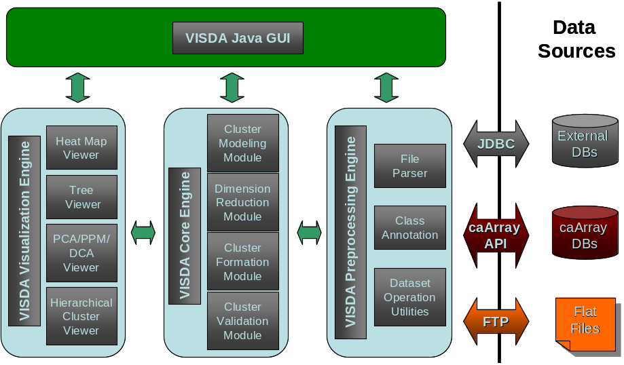
Figure 4.1. The VISDA system architecture overview

Architectural Design
As outlined in the architectural design of VISDA, the four major components will be implemented in this project: (1) VISDA Java GUI Engine, (2) VISDA Preprocessing Engine, (3) VISDA Core Engine, and (4) VISDA Visualization Engine. The class objects and their relations are designed using Unified Modeling Language (UML). Figure 4.2 shows a UML sequence diagram to lay out a potential flow of events in using VISDA.

VISDA GUI Engine
A Java-based user friendly GUI will be developed as a main entry to perform initial set-up, data input-output, data analysis, and data/results visualization actions by calling VISDA APIs. In other words, GUI engine is also a testing driver to test all VISDA preprocessing, core function, and visualization packages.

VISDA Preprocessing Engine
VISDA preprocessing engine will interact with data sources such as caArray database, local MAGE-ML files, and tab-delimited text files. Data importing and parsing APIs will be implemented by utilizing caArray MAGE-OM and MAGEstk APIs. VISDA preprocessing engine will also perform major data preprocessing tasks, such as data parsing, data merging, and class (sample) annotation, and then make the data available to the VISDA core engine.

VISDA Visualization Engine
All necessary data profile display, intermediate and final result display will be implemented in the VISDA visualization engine.

VISDA Core Engine
In the VISDA core engine, the following modules will be implemented: (1) Cluster Modeling Module (CMM), (2) Dimension Reduction Module (DRM), (3) Cluster Formation Module (CFM), and (4) Cluster Validation Module (CVM). They compose of the essential part of the VISDA approach. A detailed description of each module is in Appendix B.
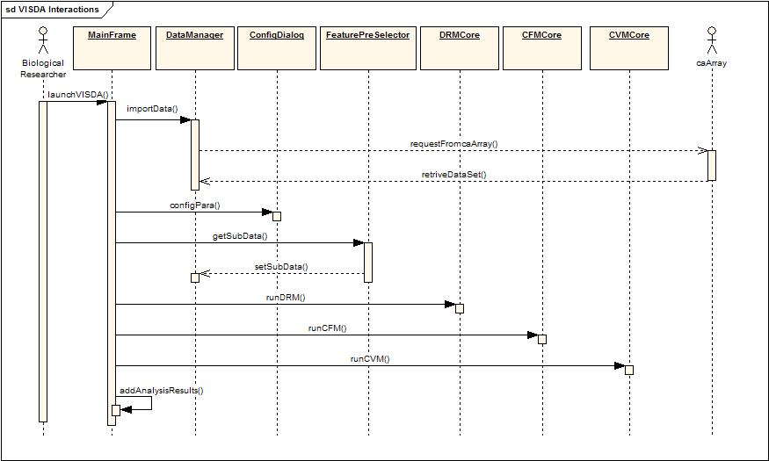
Figure 4.2. VISDA UML sequence diagram

Components
This section describes the components in detail and serves as a reference for the project developers and maintainers.

VISDA GUI Module

Visda
Type: public Class
Purpose: Serves as a main entry for VISDA
Packages: edu.vt.cbil.visda

Visda Attributes
Attribute | Type | Notes
_TITLE | public static final :  java.lang.String | The name of the program.
_VERSION | public static final :  java.lang.String | The version of the program.

Visda Methods
Method | Type | Notes
Visda () | public: | The main class to launch VISDA
main( String[] ) | public static: void | param: args [String[] - in ]  -- void main(String[]

MainFrame
Type: public Class
Purpose: Serves as a main GUI for VISDA
Packages: edu.vt.cbil.visda

MainFrame Attributes
Attribute | Type | Notes
title | public static final :  java.lang.String | The name of the program.
version | public static final :  java.lang.String | The version of the program.
chooser | public : JFileChooser
properties | private : Properties
configParaAction | public : Action | Method to configure parameters
importDataAction | public : Action | Method to import data
runVisdaAction | public : Action | Method to run VISDA analysis
viewOutcomeAction | private : Action | Method to view results
exitAction | private : Action | Method to exit the program

MainFrame Methods
Method | Type | Notes
MainFrame () | public:
ConfigParaAction() | private : class | Method to configure parameters
ImportDataAction() | private : class | Method to import data
RunVisdaAction() | private : class | Method to run VISDA analysis
ViewOutcomeAction() | private : class | Method to view results
ExitAction() | private : class | Method to exit the program
initialize() | private : void
createActions() | private : void
createFileMenu() | private : void
cleanUp() | private : void

ConfigDialog

Type: public Class
Purpose: performs configuration of all necessary parameters for VISDA
Packages: edu.vt.cbil.visda

ConfigDialog Attributes
Attribute | Type | Notes
numUsedFeatures | public static : int | “0” means using all features  1<= numUsedFeatures<total number of features
numHLevels | public static : int | The deepest number of hierarchical level of the tree. It must be smaller than the size of samples.
similarityMetric | public static : string | Metric method to measure similarity, e.g. “Euclean Distance”
clusterMethod | public static : string | Linkage method to cluster, e.g. “averaged linkage”
phenotypeCluFlag | public static : Boolean | “true” means to perform sample clustering
geneCluFlag | public static : Boolean | “true” means to perform gene clustering
configAction | public : Action
cancelAction | public : Action

ConfigDialog Methods
Method | Type | Notes
ConfigDialog () | public:
ConfigAction() | private : class
CancelAction() | private : class
initialize() | private : void
createActions() | private : void

VISDA data preprocessing Module

MicroarrayDataInput
Type: public Class
Purpose: Serves as a data parser for VISDA
Packages: edu.vt.cbil.visda.data

MicroarrayDataInput Attributes
Attribute | Type | Notes
data | public : double [][] | Dimension: data[numGenes][ numSamples]
numGenes | protected : int | Total number of genes in the dataset
numSamples | protected : int | Total number of samples in the dataset
geneNames | public : String[] | Dimension: geneNames[numGenes]
geneIDs | public : String[] | Dimension: geneIDs [numGenes]
geneAccessNums | public : String[] | Dimension geneAccessNums [numGenes]
sampleNames | public : String[] | Dimension sampleNames [numSamples]
sampleLabels | public : int[] | Dimension sampleLabels [numSamples

MicroarrayDataInput Methods
Method | Type | Notes
MicroarrayDataInput () | public:
readfromtextfile(String) | public : void | param: filename [String - in ]  -- void readfromtextfile (String)
readfromcaArray(String) | public : void | param: expID [String - in ]  -- void readfromcaArray (String)

DataManager
Type: public Class
Purpose: Holds references to all data that should be available to all parts of the application for VISDA
Packages: edu.vt.cbil.visda.data

DataManager Attributes
Attribute | Type | Notes
current | private static : DataManager | current singleton
data | public : double [][] | Dimension: data[numGenes][ numSamples]
numGenes | protected : int
numSamples | protected : int
geneNames | public : String[]
geneIDs | public : String[]
geneAccessNums | public : String[]
sampleNames | public : String[]
sampleLabels | public : int[]
numUsedFeatures | public static : int | Number of used genes (features)
numHLevels | public static : int
similarityMetric | public static : string
clusterMethod | public static : string
phenotypeCluFlag | public static : Boolean
geneCluFlag | public static : Boolean
selectedData | public static : double [][] | Dimension:  data[numUsedFeatures][ numSamples]
selectedFeatureIndex | public static : int[] | Dimension:  selectedFeatureIndex [numUsedFeatures]

DataManager Methods
Method | Type | Notes
DataManager () | public:
getInstance() | public static : DataManager | the only way to get an instance of the singleton
getGeneNames() | public : String[]
getGeneIDs() | public : String[]
getGeneAccessNums() | public : String[]
getSampleNames() | public : String[]
getSampleLabels() | public : int[]
getNumGenes() | public : int
getNumSamples() | public : int
getCurrentData() | public : double[][]
setGeneNames(String[]) | public : void
setGeneIDs(String[]) | public : void
setGeneAccessNums(String[]) | public : void
setSampleNames(String[]) | public : void
setSampleLabels(int[]) | public : void
setNumGenes(int) | public : void
setNumSamples(int) | public : void
setCurrentData(double[][]) | public : void
setCurrentSelectData(double[][]) | public : void
setCurrentSelectFeatureIndex(int[]) | public : void
setCurrentConfigPara(int, int, String, String, Boolean, Boolean) | public : void

FeaturePreSelector
Type: public Class
Purpose: Serves as a feature pre-selection to reduce the dimensionality for VISDA
Packages: edu.vt.cbil.visda.data

FeaturePreSelector Attributes
Attribute | Type | Notes
numSelectedFeatures | public : int | “0” – using all features
clusteringIndicator | public : int | “0” – array clustering  “1” – gene clustering
data | public : double [][]
selectedData | public : double [][]
selectedFeatureIndex | public : int[]
numGenes | public : int
numSamples | public : int
geneNames | public : String[]
geneIDs | public : String[]
geneAccessNums | public : String[]
sampleNames | public : String[]
sampleLabels | public : int[] | Class label, i.e., 1 – class 1, 2 – class 2, etc.
sortedPerformanceIndex | public : double[] | Holds sorted SNR values or variances for each feature
chooser | public : JFileChooser

FeaturePreSelector Methods
Method | Type | Notes
FeaturePreSelector () | public:
snrSupervised(double[][], int[], int) | public : int[] | param:data [double[][] - in ]  label [int[] - in ]  numFeatures [int – in]  return: selectedFeatureIndex [int[]]
varUnsupervised(double[][], int) | public : int[] | param:data [double[][] - in ]  numFeatures [int – in]  return: selectedFeatureIndex [int[]]
saveFeatureList (File) | public : void | Method to save the gene list used for array clustering

VISDA core Module

DRMCore
Type: public Class
Purpose: performs a portfolio of discriminatory data projections for exploratory cluster visualization for VISDA
Packages: edu.vt.cbil.visda.comp

DRMCore Attributes
Attribute | Type | Notes
numFeatures | public : int
numSamples | public : int
sampleLabels | public : int[] | Class label, i.e., 1 – class 1, 2 – class 2, etc.
level | public : int | Hierarchical level, e.g., level = 1 for top level.
data | public : double [][] | Input data, n x p.  Array clustering:  n: samples, p: dimensions (genes)  Gene clustering:  n: genes, p: dimensions (samples)
dataProj | public : double [][] | Data projected onto the space defined by the principal components
pcVectors | public : double [][] | Principal components (eigenvectors). Each column is an eigenvector, and all eigenvectors are sorted from left to right based on their associated eigenvalues in descending order.
top2PCVectors | public : double [][] | Top two principal components resulting from PCA
top2PCPPMVectors | public : double [][] | Top two principal components resulting from PCA/PPM
top2HCDCAVectors | public : double [][] | Top two principal components resulting from HCDCA
covCluster | public : double [][] | Covariance matrix of the sub-cluster estimated by EM algorithm at the immediate upper level. Note that it is used for sub-clusters only.
meanCluster | public : double [][] | Means of clusters estimated at the upper level. They are used for centering data points in each sub-windows corresponding to each of the cluster at the upper level.
Zjk | public : double [] | Posterior probabilities of all samples belonging to one cluster at the upper level. At top level, Zjk is a vector whose elements are all “1”s. At sub-levels, Zjk is used for determining the color density of each data point in the each plot.
clusterInx | public : int[] | Cluster or sub-cluster number

DRMCore Methods
Method | Type | Notes
DRMCore(int,int) | public : class
vePCA(double[][]) | public: void | Method to perform PCA analysis at top level
veSubPCA(double[][],double[][]) | public: void | Method to perform PCA analysis at sub level
vePCAPPM(double[][]) | public: void | Method to perform PPM analysis at top level
veSubPCAPPM(double[][],double[][],double[][]) | public: void | Method to perform PPM analysis at sub level
veHCDCA(int,double[][],double[][],double[][],…) | public: void | Method to perform HC-DCA analysis at sub level
veProjection(int, double[][],double[][], int[],double[], double, double[][], int) | public: void | Generate PCA and PCA-PPM projections, and allow the user to select one projection for the current cluster or sub-cluster visualization at current level

CFMCore
Type: public Class
Purpose: performs clustering model formulation (parameter estimation using EM) task for VISDA
Packages: edu.vt.cbil.visda.comp

CFMCore Attributes
Attribute | Type | Notes
w0_t | public : double [] | Mixing proportions of the identified clusters in t-space.
numFeatures | public : int
numSamples | public : int
mean_t | public : double [][] | Means of clusters in t-space.
cov | public : double [][] | Covariance matrices of clusters in t-space.
inv_cov | public : double [][] | Inverse of a covariance matrix.
cov_mat | public : double [][] | Adjusted covariance matrix.
det_cov | public : double [][] | Determinant of the adjusted covariance matrix.
Zjk | public : double [][] | Posterior probabilities of all samples belonging to all clusters, each column is for one cluster.
mean_x | public : double [][] | Means of clusters estimated by x-space (2-D) EM algorithm. They are used for initializing the t-space EM algorithm.
Zjk_x | public : double [][] | Posterior probabilities estimated by x-space (2-D) EM algorithm, each column is for one cluster.
w0_x | public : double[] | Mixing proportion of clusters estimated by x-space (2-D) EM algorithm.

CFMCore Methods
Method | Type | Notes
CFMCore(int,int) | public : class
veSubEM (double[][],double[][]) | public: void | Perform t-space EM algorithm at all levels
veCov(double[][]) | public: void | Calculate and approximate (if singular) the inverse of a covariance matrix.

CVMCore
Type: public Class
Purpose: performs clustering model selection and validation tasks for VISDA
Packages: edu.vt.cbil.visda.comp

CVMCore Attributes
Attribute | Type | Notes
numFeatures | public : int
numSamples | public : int
k0 | public : int | Final selected number of clusters by either the user or MDL.
mu_t | public : double [][] | Means of clusters in original t-space, they are transformed from means in 2-D space (estimated by 2-D EM algorithm). Each row is the mean of one cluster.
w0 | public : double [] | Mixing proportion (prior probabilities) for each cluster.
Zjk_t | public : double [][] | Posterior probabilities of all samples belonging to all clusters, each column is for one cluster.
vk0 | public : int[] | Cluster splitting indices. It indicates the parent cluster from that each current sub-cluster splits.  Example: if vk0 = [1 1 2 2 3], it means that the sub-cluster #1 & #2 split from cluster #1 at the upper level, the sub-cluster #3 & #4 split from cluster #2 at the upper level, and the sub-cluster #5 is cluster #3 (not split) at the upper level.
w2 | public : double[] | “Conditional” mixing proportion (prior probabilities) of each sub-cluster.  Example: w0 = [0.6 0.4 0.2 0.8] indicates that the proportions of sub-cluster #1 and #2 within cluster #1 at the upper level at 0.6 and 0.4 respectively, and the proportions of sub-cluster #3 and #4 within cluster #2 at the upper level at 0.2 and 0.8 respectively.

CVMCore Methods
Method | Type | Notes
CVMCore(int,int) | public : class
veMselect2 (int,double[][],double[][]) | public: void | Offer model selection at sub-levels, including cluster initialization, x-space (2-D) EM clustering, and MDL validation
veMselect (double[][],double[][]) | public: void | Offer model selection at top level, including cluster initialization and MDL validation

VISDA Visulization Module

TreeViewTools
Type: public Class
Purpose: visualizes treeview plots for VISDA
Packages: edu.vt.cbil.visda.view

TreeViewTools Methods
Method | Type | Notes
TreeViewTools() | public : class
dendrogram(double[][]) | public: void | Generate dendrogram plot.  DENDROGRAM(Z) generates a dendrogram plot of the hierarchical binary cluster tree Z. Z is an (M-1)-by-3 matrix, generated by the LINKAGE function, where M is the number of objects in the original dataset.

2DPlotTools
Type: public Class
Purpose: performs GUI-related work in a dedicated thread for VISDA
Packages: edu.vt.cbil.visda.view

2DPlotTools Methods
Method | Type | Notes
2DPlotTools () | public : class
MDLPlot(double[]) | public: void | Generate MDL plot.  MDLPlot (Z) generates a MDL plot. Z is an Kx1 vector, contains MDL values, where K is the total number of clusters.
projectionPlot(double[][],int[],double[]) | public: void | Generate 2-D projection plot.  projectionPlot (Z, label, Zjk) generates a 2D projection plot. Z is an Mx2 matrix, label is an Mx1 vector , Zjk is an Mx1 vector, where M is the number of objects in the original dataset.

VISDA utilitieS Module

SwingWorker
Type: public abstract Class
Purpose: performs GUI-related work in a dedicated thread for VISDA
Packages: edu.vt.cbil.visda.util

SwingWorker Methods
Method | Type | Notes
SwingWorker() | public abstract : class
construct() | public abstract : Object
start() | public: void
setPriority (int) | public : void

MathTools
Type: public Class
Purpose: Serves as a placeholder for commonly used mathematical functions, vector and matrix operations for VISDA
Packages: edu.vt.cbil.visda.util

MathTools Methods
Method | Type | Notes
MathTools () | public:
max(double[]) | public static: double | param: array [double[] - in ]  -- double max(double[])  Return the maximum value of a array
min(double[]) | public static: double | param: array [double[] - in ]  -- double min(double[])  Return the minimum value of a array
mean(double[]) | public static: double | param: array [double[] - in ]  -- double mean(double[])  Return the mean of a array
var(double[]) | public static: double | param: array [double[] - in ]  -- double var(double[])  Return the variance of a array
sort(double[]) | public static: double [] | param: array [double[] - in ]  -- double [] sort(double[])  Sorting a array
eig(double[][],double[][],double[][]) | public static: void | param: inMatrix [double[][] - in ]  param: eigVectors [double[][] - out ]  param: diagEigVal [double[][] - out ]  Computing the eigen value and eigen vector of a matrix
diag(double[][]) | public static: double[][] | Diagonal matrices and diagonals of a matrix.
norm(double[][]) | public static: double | Computing the norm of a matrix

HCTools
Type: public Class
Purpose: Servers as basic functions computation of hierarchical clustering and K-means initialization for VISDA
Packages: edu.vt.cbil.visda.util

HCTools Methods
Method | Type | Notes
HCTools () | public:
pdist(double[][],String) | public static: double[] | Pairwise distance between observations.  param: data [double[][] - in ]  distance [String – in]  Y = pdist(X, distance) returns a vector Y containing the Euclidean distances between each pair of observations in the N-by-P data matrix X. Rows of X correspond to observations, columns correspond to variables. Y is a 1-by-(N*(N-1)/2) row vector, corresponding to the N*(N-1)/2 pairs of observations in X.
linkage(double[],String) | public static: double[][] | Create hierarchical cluster tree.  param: Y [double[] - in ]  linkage_method [String – in]  return: a Cluster information will be returned in the matrix Z with size m-1 by 3, where m is the number of observations in the original data.  The input Y is a distance matrix such as is generated by PDIST.
squareform(double[]) | public static: double[][] | Square matrix formatted distance.  param: Y [double[] - in ]  return: Z = squareform(Y) converts the output of PDIST function into a square format, so that Z(i,j) denotes the distance between the i and j objects in the original data.  Y is a 1-by-(N*(N-1)/2) row vector, corresponding to the N*(N-1)/2 pairs of observations in X. Z is a N*N matrix
cophenet(double[][],double[]) | public static: double | Computes the Cophenetic coefficient between the distance of the cluster tree in Z and the distance in Y. Z is the output of the function linkage(). Y is the output of the function pdist().
cluster(double[][],String,double) | public static: double | CLUSTER Construct clusters from LINKAGE output.  T = CLUSTER(Z,'CUTOFF',C) constructs clusters from cluster tree Z. Z is a matrix of size M-1 by 3, generated by LINKAGE. C is a threshold for cutting the hierarchical tree generated by LINKAGE into clusters. Clusters are formed when inconsistent values are less than CUTOFF. The output T is a vector of size M that contains the cluster number for each observation in the original data.
kmeans(double[][],int) | public static: int[] | KMEANS K-means clustering.  IDX = KMEANS(X, K) partitions the points in the N-by-P data matrix X into K clusters.  This partition minimizes the sum, over all clusters, of the within-cluster sums of point-to-cluster-centroid distances. Rows of X correspond to points, columns correspond to variables. KMEANS returns an N-by-1 vector IDX containing the cluster indices of each point. By default, KMEANS uses squared Euclidean distances.

FCTools
Type: public Class
Purpose: Calculates original Fisher scatter matrix and weighted Fisher scatter matrix for VISDA
Packages: edu.vt.cbil.visda.util

FCTools Attributes
Attribute | Type | in/out | Notes
sbsw | public static: double [][] | OUT | Scatter matrix of S_{b}S_{w}⁻¹
swsb | public static: double [][] | OUT | Scatter matrix of S_{w}⁻¹S_{b}
sb | public static: double [][] | OUT | Scatter matrix of S_{b}
sw | public static: double [][] | OUT | Scatter matrix of S_{w}
w_swsb | public static: double [][] | OUT | Weighted Fisher scatter matrix.
sub_clt | public static: int | OUT | Number of sub-clusters in the current level
w0_t_clt | public static: double [] | IN | Mixing proportion of sub-clusters in the parent cluster or sub-cluster at the upper level
mu_clt | public static: double [][] | IN | Means of sub-clusters in the parent cluster or sub-cluster at the upper level
cov_mat_clt | public static: double [][] | IN | Covariance matrices of sub-clusters in the parent cluster or sub-cluster at the upper level

FCTools Methods
Method | Type | Notes
FCTools () | public:
veSBSW(double[][], int[]) | public static: void | param: data [double[][] - in ]  label [int[] – in]  Calculate original Fisher scatter matrix.
veWSBSW(double[][],double[][],double[][]) | public static: void | Calculate weighted Fisher scatter matrix.

Sign off

Approval

Patrick McConnell 5/31/05
Architecture Workspace Rep (Duke) Print Name Date
Lynne R. Wilkens Lynne R. Wilkens 8/10/05
VCDE Workspace Rep Print Name Date
Louise C.Showe Louise C. Showe 5/20/05
Adopter Rep (Univ. of Pennsylvania) Print Name Date

Appendix A – Acronym List
Term/  Abbreviation | Description
VISDA | Visual and Statistical Data Analyzer
BLAS | Basic Linear Algebra Subprograms
JAMA | Java Matrix Package
API | Application Programmer Interface
caBIG | cancer Biomedical Informatics Grid
CDE | Common Data Elements
CVS | Concurrent Versions System
DBA | Database Administrator
GUI | User Graphical Interface
ICR | Integrative Cancer Research
MAGE-OM | Microarray Gene Expression Object Model
PM | Project Manager
RM | Requirements Manager
RTM | Requirements Traceability Matrix
SCM | Software Configuration Management
SDLC | Software Development Lifecycle
SDP | Software Development Plan
SE | Software Engineering
SEPG | Software Engineering Process Group
SM | Software Manager
SOP | Standard Operating Procedure
SPI | Software Process Improvement
SQA | Software Quality Assurance
SRSD | Software Requirements and Specification Document
SW | Software
TBD | To Be Determined
UML | Unified Modeling Language

Appendix B – Detail DescriptioN of visda core engine
Cluster Modeling Module (CMM): we will use standard finite normal mixture (SFNM) to make the model analytically tractable while maintaining the ability to describe arbitrary sources. This enables us to apply EM algorithm and MDL criterion to estimate model parameters and detect model structure. The data distribution across tissue samples takes a sum of the following general form, i.e., hierarchical SFNM distribution:
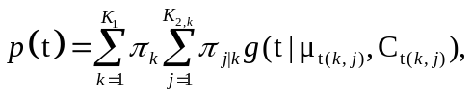 (1)
where π_{k} is the relative mass of cluster k, g is the Gaussian kernel, and θ_{k} (={μ_{k}, C_{k} }) is the kernel parameter vector of the cluster k. The problem of SFNM modeling addresses the combined estimation of regional parameters (π_{k}, θ_{k}) and detection of the structural parameter K₀ (=K₁×K_{2,k}). Implementation is in Section 5.3.2.

Dimension Reduction Module (DRM): In VISDA we will develop a portfolio of discriminatory data projections for exploratory cluster visualization, including PCA/PCA-PPM method and wFC-DCA method as described below. Implementation is in Section 5.3.1.

(1) PCA/PCA-PPM: Initial projection will be achieved by either PCA or PCA-PPM method. For a set of d-dimensional data vectors, the q principal axes are those orthogonal axes onto which the retained variance under projection is maximal, which correspond to the q dominant eigenvectors of the covariance matrix. As we know, PCA is suboptimum for cluster discovery. In VISDA, we will enhance the PCA project with a completely unsupervised method, namely projection pursuit method (PPM) that uses higher-order statistics (i.e., kurtosis vs. variance), to emphasize the discovery of nonlinear effects for clustering. Specifically, PCA-PPM method will select the most discriminatory PCA projections according to their normalized kurtosis.
(2) wFC-DCA: Upon a SFNM-EM-MDL model fitting, we will further refine the projection by using wFC-DCA approach. The optimal projection W is determined which maximizes weighted Fisher criterion in Eq. (2):
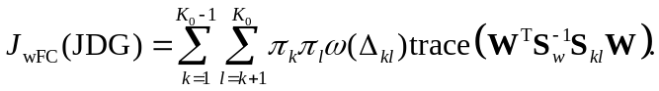 (2)
Our experience on many microarray datasets shows that wFC-DCA cluster visualization provides close to optimal supervised solution when SFNM modeling of the data is adequate. The determination of W can be carried out by solving the following generalized eigenvalue problem:
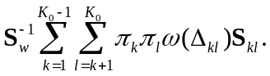 (3)
Cluster Formation Module (CFM): The parameters of an SFNM model can be optimally estimated by maximum likelihood (ML) estimation. Specifically, we will apply the expectation-maximization (EM) algorithm to perform such ML estimation. The EM algorithm can be informally summarized as follows. The EM algorithm starts with randomly assigning values to all the parameters to be estimated. It then iteratively alternates between two steps, called the expectation step (i.e., the “E-step”) and the maximization step (i.e., the “M-step”), respectively. In the E-step, it computes the expected likelihood for the complete data where the expectation is taken with respective to the computed conditional distribution of the latent variables (i.e., the “clusters”), given the current settings of parameters and our observed data. In the M-step, it re-estimates all the parameters by maximizing the likelihood function. Once we have a new generation of parameter values, we can repeat the E-step and another M-step. This process continues until the likelihood converges, i.e., reaching a local maximum. Implementation is in Section 5.3.2.
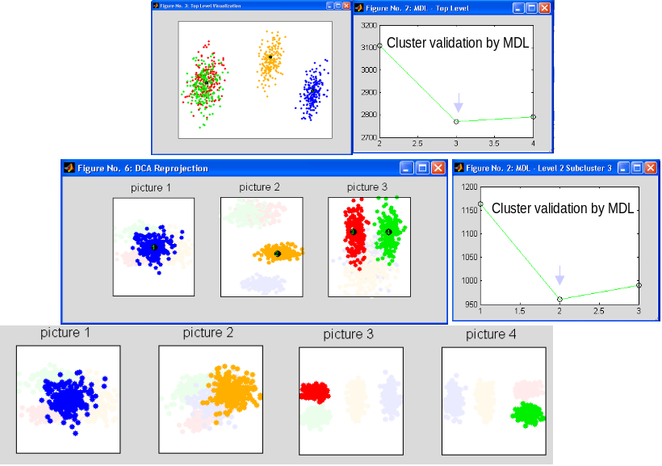
Figure B.1. Multi-level hierarchical cluster discovery by VISDA.

Cluster Validation Module (CVM): In addition to user's visual inspection, we will use minimum description length (MDL) criterion to guide and validate cluster selection. MDL is a proven criterion to perform a statistically principled cluster validation, and has proven asymptotically consistent (e.g., converges in probability to the true model order when N→∞). The major thrust of this approach has been the formulation of a model fitting procedure in which an optimal model is selected from the several competing candidates such that the selected model best fits the observed data. The “U” shape of the MDL curve is referred to as the so-called bias/variance dilemma:
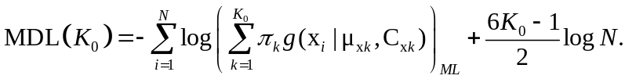 (4)
In particular, we will calculate the values of the MDL function for K₀ = K_{min}, …, K_{max}, and select a model with K₀ which corresponds to the minimum MDL value (see Figure B.1). Implementation is in Section 5.3.3.

